**SECURIN ASSIGNMENT**

**PROBLEM STATEMENT: THE DOOMED DICE CHALLENGE**

**PART A:**

1. How many total combinations are possible?

CODE:

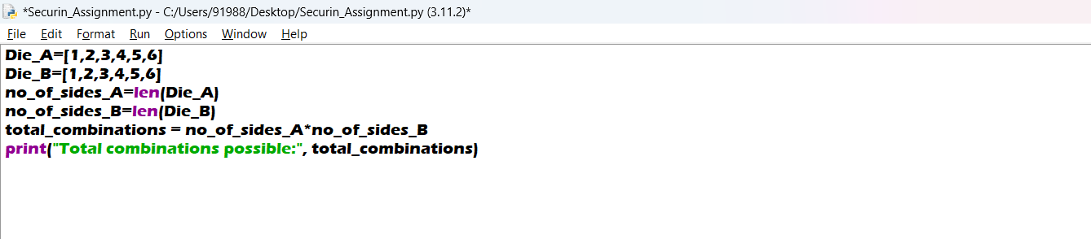

OUTPUT:



2. Calculate and display the distribution of all possible combinations that can be obtained when rolling both Die A and Die B together. Show the math along with the code.

CODE:

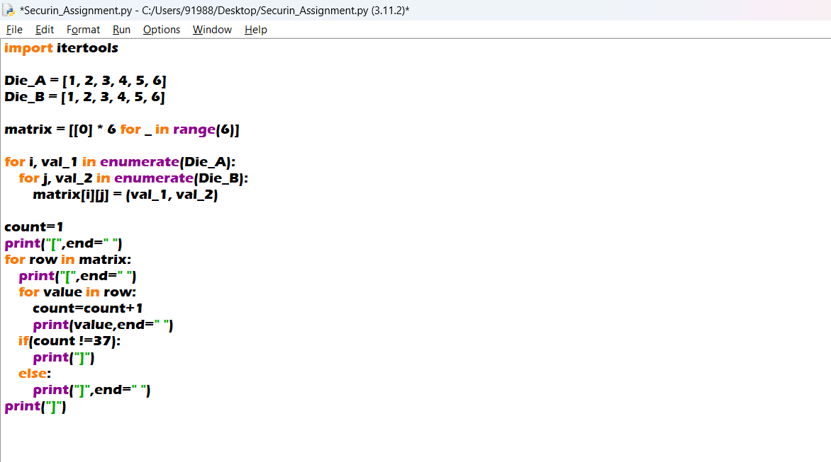

OUTPUT:

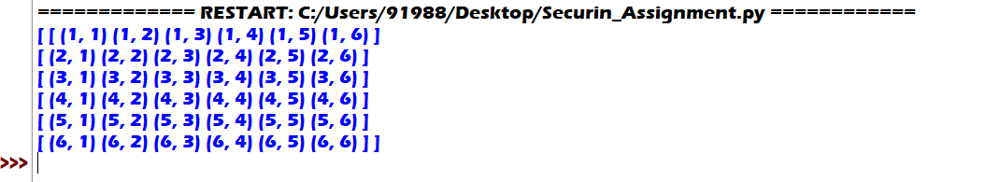

3. Calculate the probability of all possible sums occurring among the number of combinations from (2).

CODE:

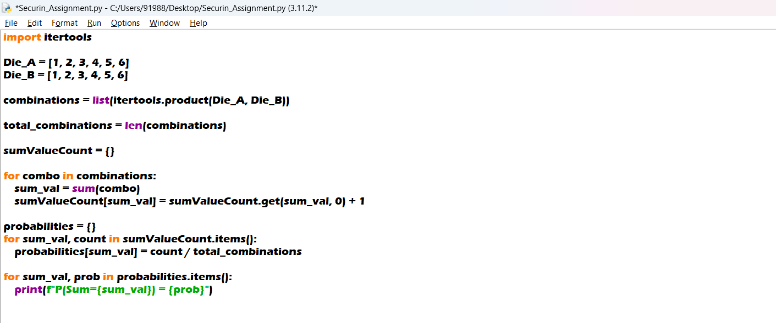

OUTPUT:

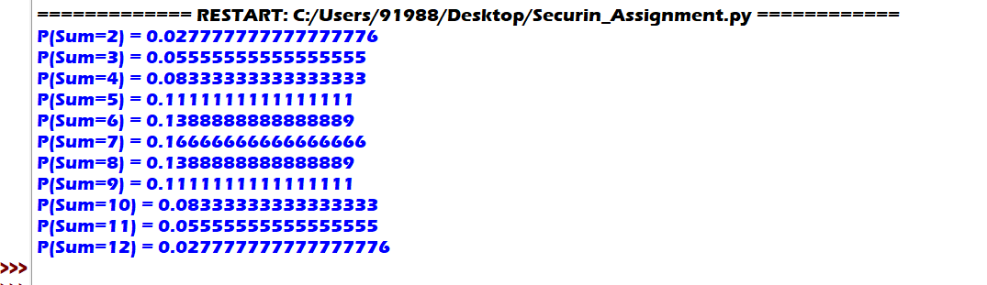

**PART B:**

Conditions to be met:

* Die A cannot have more than 4 spots on a face
* Die A may have multiple faces with the same number of spots
* Die B can have as many spots on a face as necessary i.e, even more than 6.

CODE:

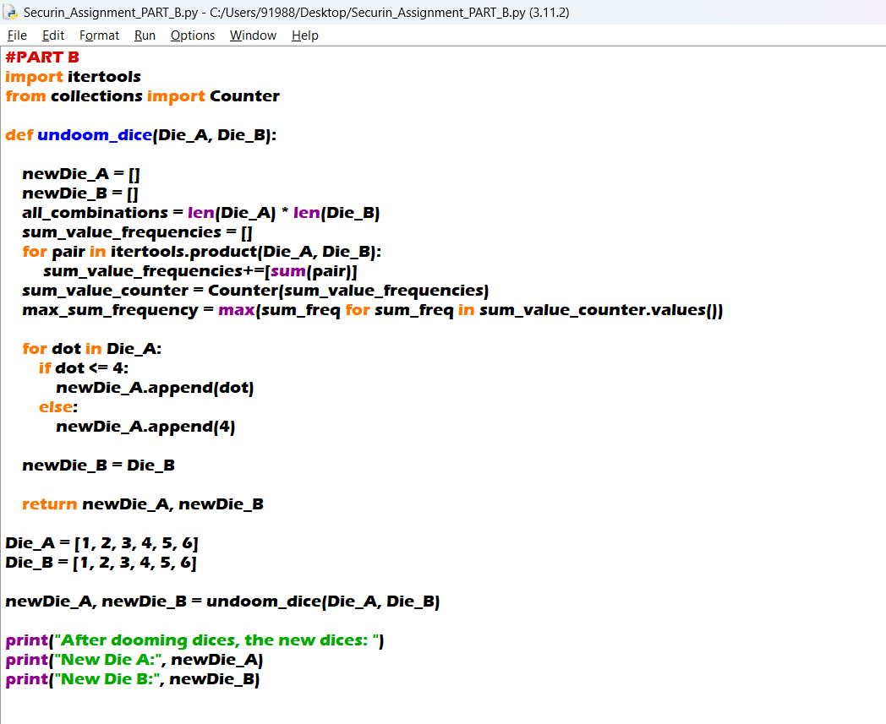

OUTPUT:

